BAZIL UDDIN KHAN
24K-0559
BSCS-3H

TASK#1).
CODE:
Include Irvine32.inc

.data
Msg1 BYTE " Bit 0 is ON ",0
Msg2 BYTE " Bit 0 is OFF ",0

.code
main PROC

mov al,10110101b
mov bl,10011101b
mov cl,11110111b

and al,01010101b
and bl,01010101b
and cl,01010101b

or al,10101010b
or bl,10101010b
or cl,10101010b

xor al,11111111b
xor bl,11111111b
xor cl,11111111b

test al,1
jnz Bit_On

Bit_OFF :
mov edx,OFFSET Msg2
call WriteString
jmp lexit

Bit_On :
mov edx,OFFSET Msg1
call WriteString
jmp lexit

lexit :
exit

main ENDP
END main

OUTPUT:
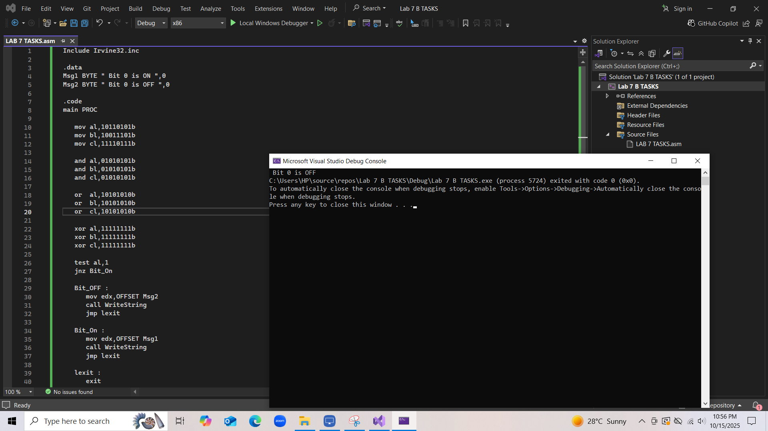

TASK#2).
CODE:
Include Irvine32.inc

.data
Num1 DWORD ?
Num2 DWORD ?
Num3 DWORD ?
SNum1 SDWORD ?
SNum2 SDWORD ?
SNum3 SDWORD ?

Msg1 BYTE " Enter a Number: ",0
Msg2 BYTE " Largest Unsigned Number = ",0
Msg3 BYTE " Largest Signed Number = ",0
Msg4 BYTE " __Signed Comparisons__",0
Msg5 BYTE " __UnSigned Comparisons__",0

.code
main PROC

mov edx,OFFSET Msg5
call WriteString
call Crlf

mov edx,OFFSET Msg1
call WriteString

mov eax,0
call ReadInt
mov Num1,eax

mov edx,OFFSET Msg1
call WriteString

mov eax,0
call ReadInt
mov Num2,eax

mov edx,OFFSET Msg1
call WriteString

mov eax,0
call ReadInt
mov Num3,eax

mov eax,Num1
cmp eax,Num2
jb Secondcheck
je Secondcheck
cmp eax,Num3
jb Secondcheck
je Secondcheck

jmp L_Print1

Secondcheck:

mov eax,Num2
cmp eax,Num1
jb Thirdcheck
je Secondcheck

cmp eax,Num3
jb Thirdcheck
je Secondcheck

jmp L_Print2

Thirdcheck :

mov eax,Num3
cmp eax,Num1
jbe L_AllEqual

cmp eax,Num2
jbe L_AllEqual
jmp L_Print3

L_Print1:
mov edx,OFFSET Msg2
call WriteString

mov eax,Num1
call WriteInt

jmp L_Signed

L_Print2:

mov edx,OFFSET Msg2
call WriteString

mov eax,Num2
call WriteInt

jmp L_Signed

L_Print3:

mov edx,OFFSET Msg2
call WriteString

mov eax,Num3
call WriteInt

jmp L_Signed

L_AllEqual :
mov edx,OFFSET Msg2
call WriteString

mov eax,Num1
call WriteInt

L_Signed:
call Crlf
mov edx,OFFSET Msg4
call WriteString
call Crlf

mov edx,OFFSET Msg1
call WriteString

mov eax,0
call ReadInt
mov SNum1,eax

mov edx,OFFSET Msg1
call WriteString

mov eax,0
call ReadInt
mov SNum2,eax

mov edx,OFFSET Msg1
call WriteString

mov eax,0
call ReadInt
mov SNum3,eax

mov eax,SNum1
cmp eax,SNum2
jl SignedSecondcheck
je SignedSecondcheck

cmp eax,SNum3
jl SignedSecondcheck
je SignedSecondcheck
jmp SL_Print1

SignedSecondcheck:

mov eax,SNum2
cmp eax,SNum1
jl SignedThirdcheck
je SignedThirdcheck

cmp eax,SNum3
jl SignedThirdcheck
je SignedThirdcheck
jmp SL_Print2

SignedThirdcheck :

mov eax,SNum3
cmp eax,SNum1
je SL_AllEqual
jl SL_AllEqual

cmp eax,SNum2
je SL_AllEqual
jl SL_AllEqual
jmp SL_Print3

SL_Print1:
mov edx,OFFSET Msg3
call WriteString

mov eax,SNum1
call WriteInt

jmp L_exit

SL_Print2:

mov edx,OFFSET Msg3
call WriteString

mov eax,SNum2
call WriteInt

jmp L_exit

SL_Print3:

mov edx,OFFSET Msg3
call WriteString

mov eax,SNum3
call WriteInt

jmp L_exit

SL_AllEqual :
mov edx,OFFSET Msg3
call WriteString

mov eax,SNum1
call WriteInt

L_exit :
exit

main ENDP
END main

OUTPUT:
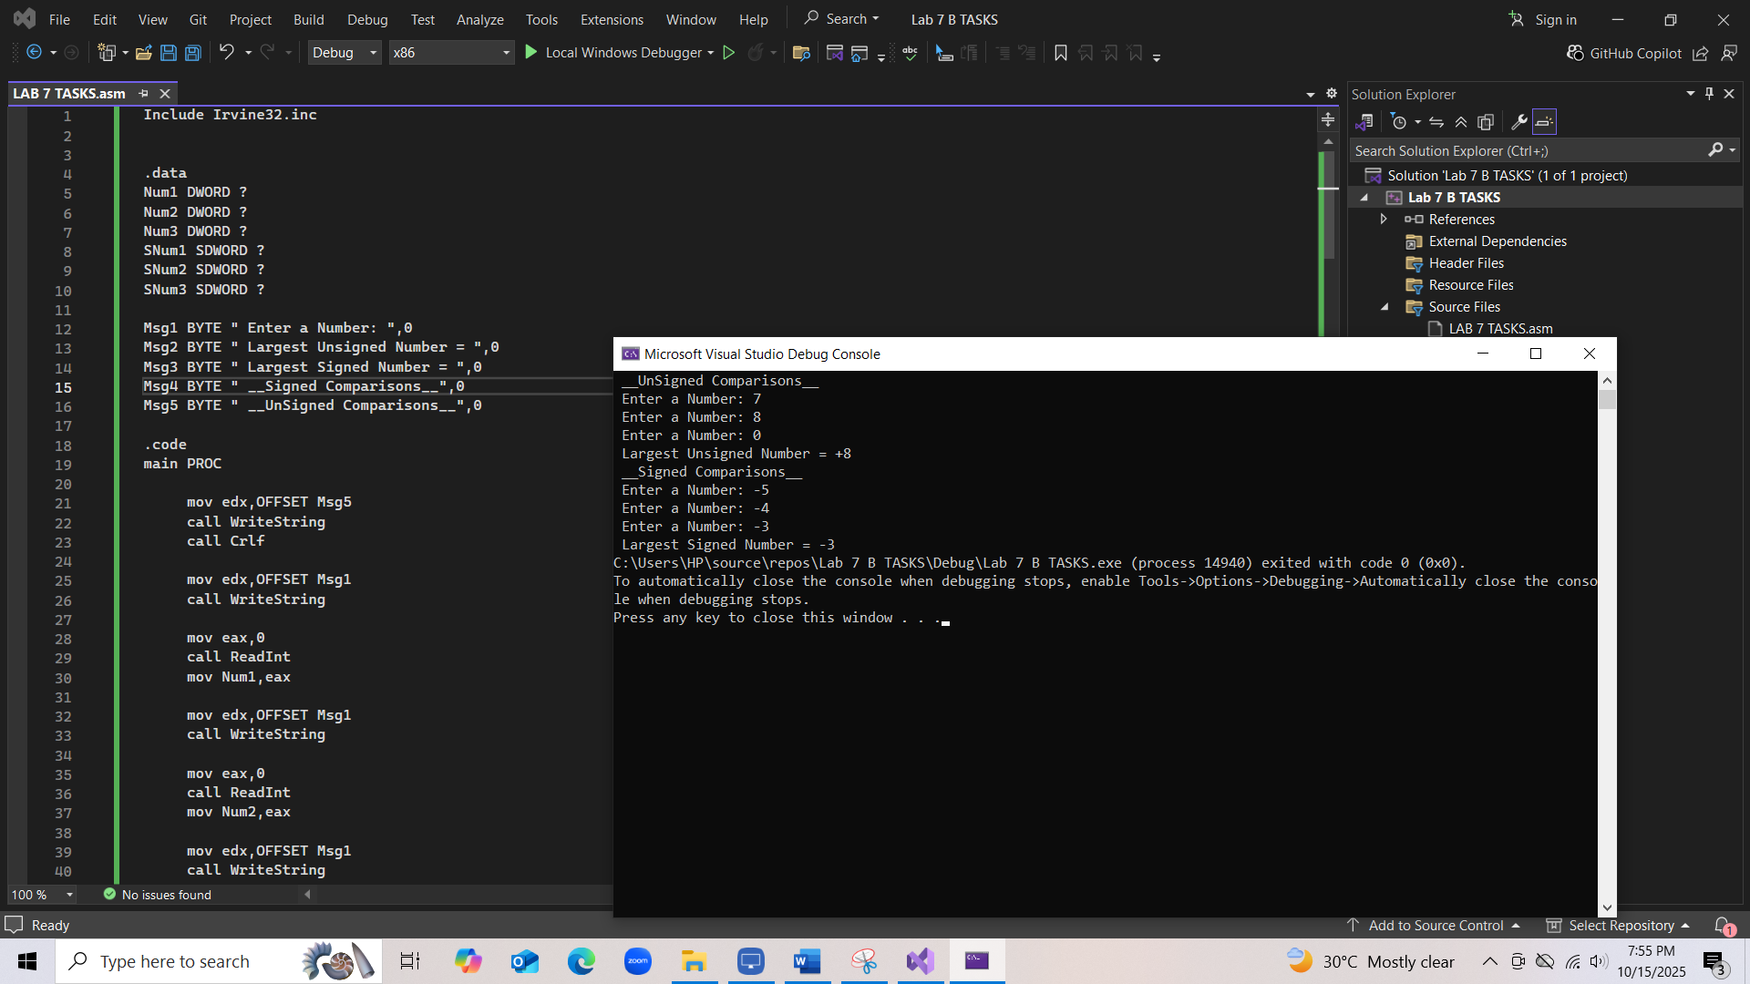

TASK#3).
CODE:
Include Irvine32.inc

.data
Count DWORD 0
Msg1 BYTE " Enter a Number: ",0
Msg2 BYTE " Total (non zero) numbers are :",0
num DWORD 0

.code
main PROC
mov ecx,5

loopv:
mov edx,OFFSET Msg1
call WriteString

mov eax,0
call ReadInt
mov num,eax

cmp eax,0
je Exit_Loop
inc Count

loopnz loopv

Exit_Loop:
mov ecx,0
mov edx,OFFSET Msg2
call WriteString
mov eax,Count
call WriteInt
call Crlf

exit

main ENDP
END main

OUTPUT:
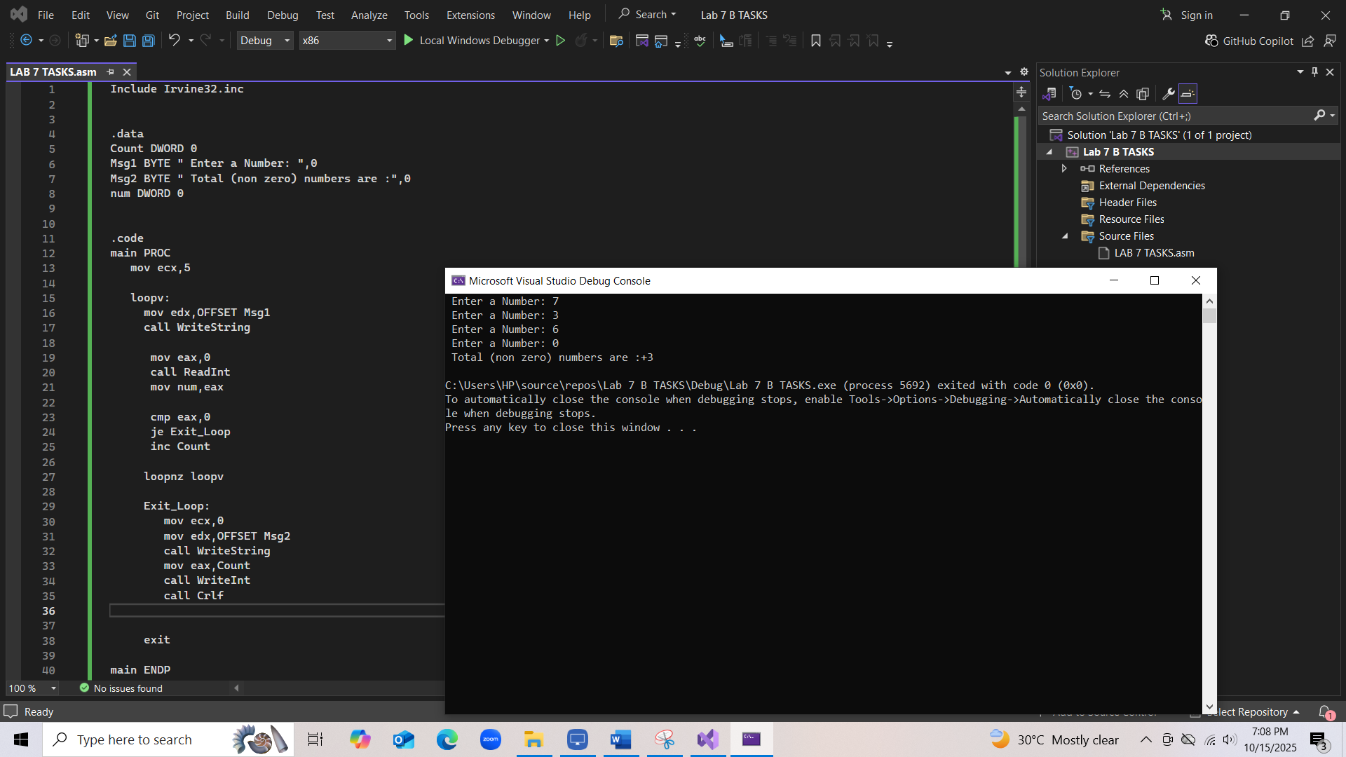

TASK#4).
CODE:
Include Irvine32.inc

.data
A SDWORD ?
B SDWORD ?
Msg1 BYTE " Enter Two Numbers: ",0
Msg2 BYTE " Condition True ",0
Msg3 BYTE " Condition False ",0

.code
main PROC
mov edx,OFFSET Msg1
call WriteString

mov eax,0
call ReadInt
mov A,eax

mov eax,0
call ReadInt
mov B,eax

mov eax,A
cmp eax,B

jle L_else

cmp eax,100
jge L_else
mov edx,OFFSET Msg2
call WriteString
jmp L_exit

L_else :
mov edx,OFFSET Msg3
call WriteString
jmp L_exit

L_exit:
exit

main ENDP
END main

OUTPUT
C CODE OUTPUT :
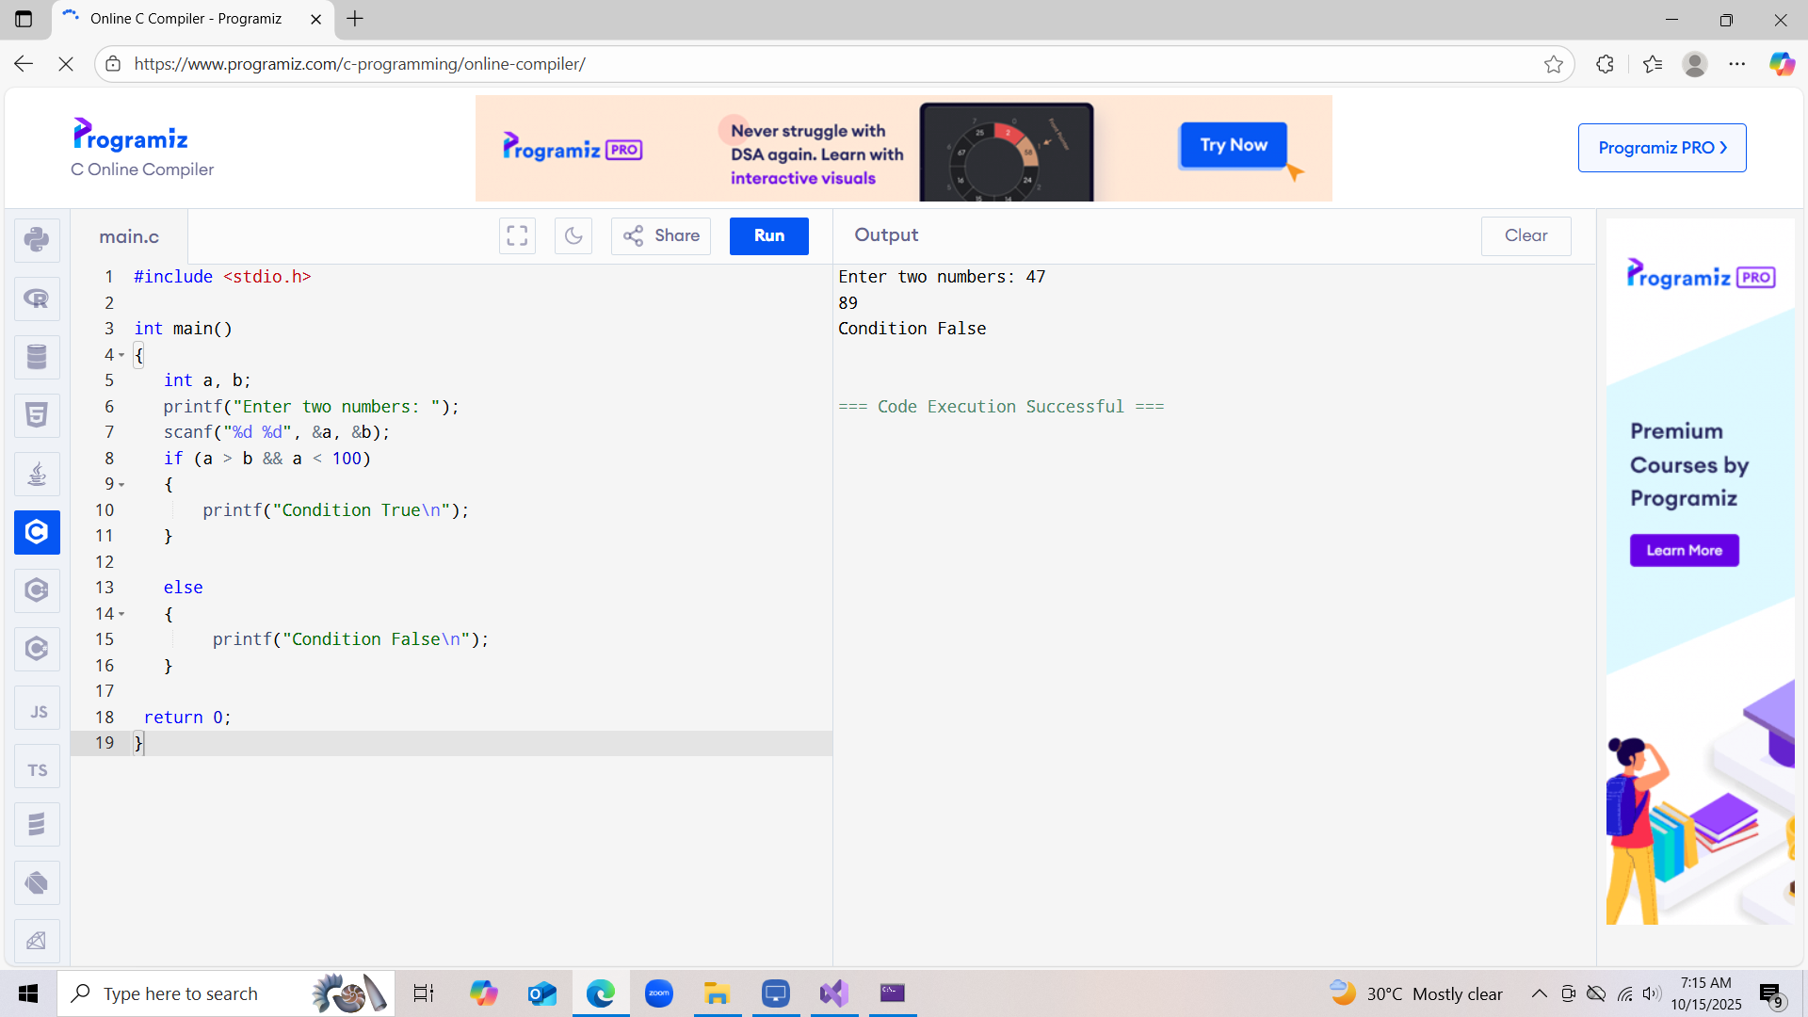

ASSEMBLY CODE OUTPUT
